
Project Evolution Report

This document presents the evolution of our graduation project idea — how it started, why it changed, and the strategic reasoning behind the transformation. The purpose is to demonstrate to investors and partners that our team analyzed the real-world feasibility and refined the concept into a more practical and innovative solution.

Initial Idea: Unified AI-Powered National Health Record Platform

Our initial concept was a nationwide Unified AI-Powered National Health Record Platform — a massive digital infrastructure to unify all patient records across hospitals in Egypt. The goal was to improve medical coordination, reduce redundant tests, and enhance emergency response.
Key Characteristics:
• National-scale platform integrating all hospitals and ambulance systems.
• AI for predictive diagnosis and medical alerts.
• High security and government-level data protection.
• Required multi-ministry collaboration and legislative approvals.

Final Idea: Integrated AI Cardiac Monitoring System

After deep analysis, the team evolved the project into a focused and executable concept — an Integrated AI Cardiac Monitoring System. This system combines wearable sensors and AI algorithms to monitor cardiac patients after surgery, predict complications, and alert physicians early.
Key Characteristics:
• IoT-based biometric sensors (Heart Rate, SpO₂, Blood Pressure, Temperature).
• Cloud-connected dashboard for physicians and patients.
• AI learns each patient’s unique health pattern for personalized predictions.
• Real-time alerts for potential cardiac risks.

4. Reasons for the Shift
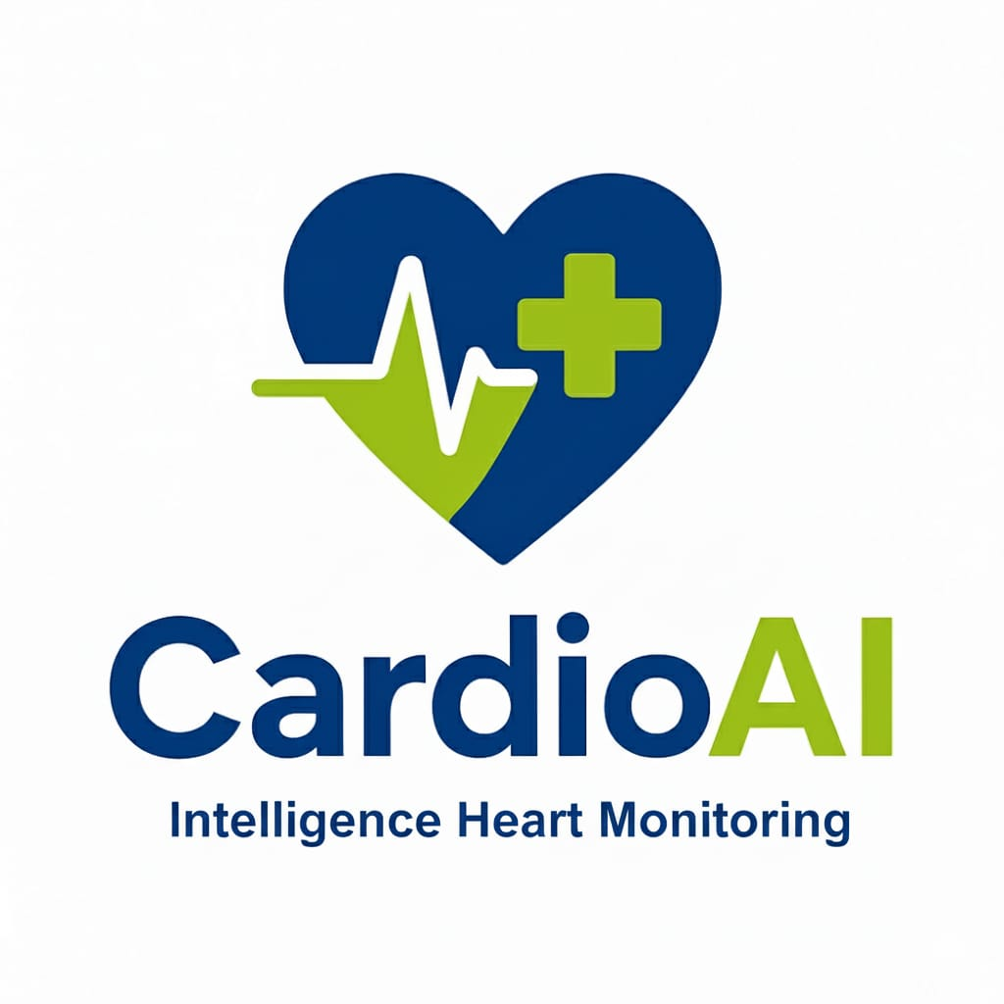

The transition from a national-scale platform to a specialized cardiac system was guided by practical, technical, and strategic considerations:
1- Feasibility — The national project required governmental collaboration and a massive infrastructure, beyond the scope of an academic or startup project.
2- Practicality — The new concept can be implemented and demonstrated as a working prototype using available university resources.
3- Scientific Depth — The cardiac monitoring system allows for applied research in biomedical data, AI modeling, and predictive healthcare.
4- Market Readiness — The medical device and health-tech sector is growing rapidly, making the new concept attractive for investors.
5- Collaboration Potential — The system aligns with Siemens Healthineers’ predictive medicine vision and can integrate easily with existing hospital technologies.

Value for Investors

The refined project offers a clear investment opportunity with measurable outcomes, scalability, and high innovation potential. By starting with cardiac monitoring, the platform can later expand to diabetes, oncology, and renal patients — forming a complete predictive healthcare ecosystem.

6. Conclusion


The evolution from a national digital health record to a focused AI-powered cardiac monitoring system demonstrates the team’s analytical mindset, technical vision, and commitment to practical innovation. The project is not only scientifically robust but also commercially viable and aligned with the global shift towards predictive and personalized medicine.

